**Data Warehouse Architectures**

There are mainly three types of Data warehouse Architectures: -

**Single-tier architecture**

The objective of a single layer is to minimize the amount of data stored. This goal is to remove data redundancy. This architecture is not frequently used in practice.

**Two-tier architecture**

Two-layer architecture separates physically available sources and data warehouse. This architecture is not expandable and also not supporting a large number of end-users. It also has connectivity problems because of network limitations.

**Three-tier architecture**

This is the most widely used architecture.

It consists of the Top, Middle and Bottom Tier.

1. **Bottom Tier:** The database of the Data warehouse servers as the bottom tier. It is usually a relational database system. Data is cleansed, transformed, and loaded into this layer using back-end tools.
2. **Middle Tier:** The middle tier in Data warehouse is an OLAP server which is implemented using either ROLAP or MOLAP model. For a user, this application tier presents an abstracted view of the database. This layer also acts as a mediator between the end-user and the database.
3. **Top-Tier:** The top tier is a front-end client layer. Top tier is the tools and API that you connect and get data out from the data warehouse. It could be Query tools, reporting tools, managed query tools, Analysis tools and Data mining tools.

**Data warehouse Components**

[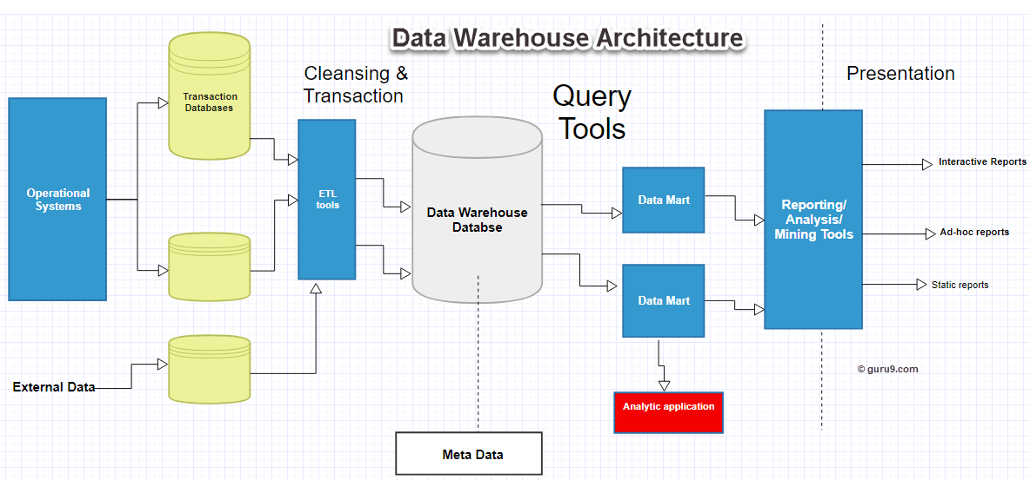](https://cdn.guru99.com/images/1/022218_0735_DataWarehou2.png)

The data warehouse is based on an RDBMS server which is a central information repository that is surrounded by some key components to make the entire environment functional, manageable and accessible

There are mainly five components of Data Warehouse:

**Data Warehouse Database**

The central database is the foundation of the data warehousing environment. This database is implemented on the RDBMS technology. Although, this kind of implementation is constrained by the fact that traditional RDBMS system is optimized for transactional database processing and not for data warehousing. For instance, ad-hoc query, multi-table joins, aggregates are resource intensive and slow down performance.

Hence, alternative approaches to Database are used as listed below-

* In a datawarehouse, relational databases are deployed in parallel to allow for scalability. Parallel relational databases also allow shared memory or shared nothing model on various multiprocessor configurations or massively parallel processors.
* New index structures are used to bypass relational table scan and improve speed.
* Use of multidimensional database (MDDBs) to overcome any limitations which are placed because of the relational data model. Example: Essbase from Oracle